1. **Basic Project Requirement:**  
   App supports multiple users via individual user accounts

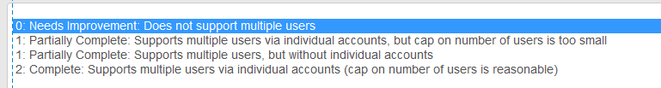

**2. Basic Project Requirement:**

App contains at least one user facing function available only to authenticated users

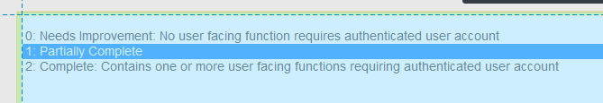

**3. Basic Project Requirement:**

App comprises at least 1 instance of each of at least 2 of the following 4 fundamental Android components:

* Activity
* BroadcastReceiver
* Service
* ContentProvider

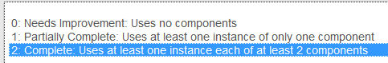

**4. Basic Project Requirement:**

App interacts with at least one remotely-hosted Java Spring-based service

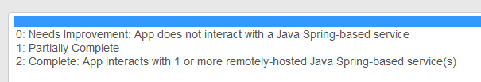

**5. Basic Project Requirement:**   
App interacts over the network via HTTP

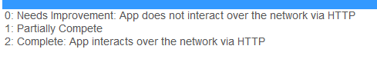

**6. Basic Project Requirement:**

App allows users to navigate between 3 or more user interface screens at runtime

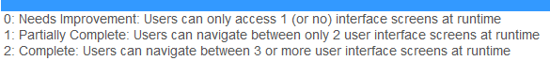

**7. Basic Project Requirement:**

App uses at least one advanced capability or API from the following list (covered in the MoCCA Specialization): multimedia capture, multimedia playback, touch gestures, sensors, animation.**

**Learners are welcome to use ADDITIONAL other advanced capabilities (e.g., BlueTooth, Wifi-Direct networking, push notifications, search), but must also use at least one from the MoCCA list.

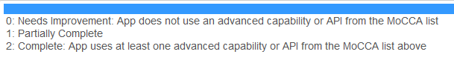

**8.  Basic Project Requirement:**  
App supports at least one operation that is performed off the UI Thread in one or more background Threads of Thread pool.



**1. Functional Description and App Requirement:**   
App identifies a Patient as a user with first name, last name, date of birth, a (unique) medical record number, and possibly other identifying information). A patient can login to their account.

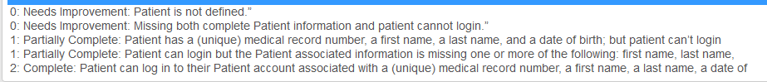

**2. Functional Description and App Requirement:**   
App defines a Reminder as an alarm or notification which can be set to patient-adjustable times (at least four times per day).

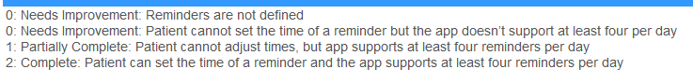

**3. Functional Description and App Requirement:**A Reminder triggers a Check-In, which is defined by the app as a unit of data associated with a Patient, a date, a time, and that patient’s responses to various questions at that date and time.



**4. Functional Description and App Requirement:** Check-In includes the question, “How bad is your mouth pain/sore throat?” to which a patient can respond, “well-controlled,” “moderate,” or “severe.

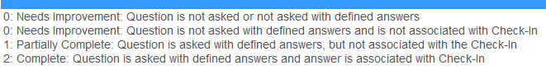

**5. Functional Description and App Requirement:**Check-In includes the question, “Did you take your pain medication?” to which a Patient can respond “yes” or “no”.

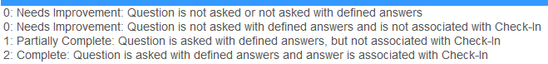

**6. Functional Description and App Requirement:**A Check-In for a patient taking more than one type of pain medication includes a separate question for each medication (e.g., “Did you take your Lortab?” followed by “Did you take your OxyContin?”). The patient can respond to these questions with “yes” or “no.”

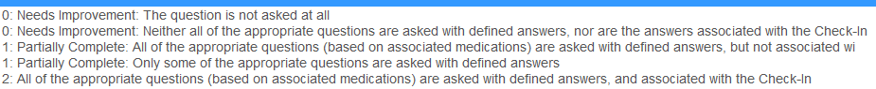

**7. Functional Description and App Requirement:**   
During a Check-In, if a patient indicates he or she has taken a pain medication, the patient will be prompted to enter the time and date he or she took the specified medicine.

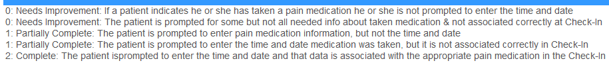

**8. Functional Description and App Requirement:**   
During a Check-In, the patient is asked “Does your pain stop you from eating/drinking?” To this, the patient can respond, “no,” “some,” or “I can’t eat.

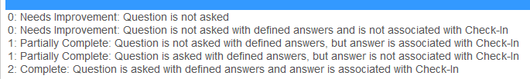

**9. Functional Description and App Requirement:**   
App defines a Doctor as a different type of user with a unit of data including identifying information (at least first name, last name, and a unique doctor ID) and an associated list of Patients that the doctor can view a list of. A doctor can login.

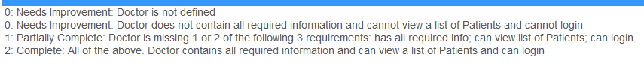

**10. Functional Description and App Requirement:**App allows a patient’s Doctor to monitor Check-Ins, with data displayed graphically. The data is updated at some appropriate interval (perhaps when a Check-In is completed).

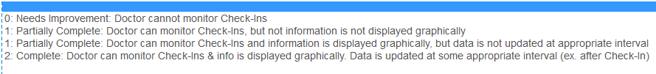

**11. Functional Description and App Requirement:**   
A doctor can search for a given Patient’s Check-In data by the patient’s name (an exact text search hosted server-side).   
Note: Non-exact text searching is not required (e.g. you don’t have to suggest, “Did you mean…”)



**12. Functional Description and App Requirement:**   
A doctor can update a list of pain medications associated with a Patient. This data updates the tailored questions regarding pain medications listed above in (6).



**13. Functional Description and App Requirement:**   
A doctor is alerted if a patient experiences 12 or more hours of “severe pain,” 16 or more hours of “moderate” or “severe pain” or 12 or more hours of “I can’t eat.”



**14. Functional Description and App Requirement:**A patient’s data should only be accessed by his/her doctor over HTTPS



<https://class.coursera.org/androidcapstone-001/forum/thread?thread_id=151>

<https://class.coursera.org/androidcapstone-001/forum/thread?thread_id=220>